Pydoc (Nathan)

USING MODULES: pydoc

Python Reference Documentation for pydoc module:

[https://docs.python.org/3/library/pydoc.htmlython version 3](https://docs.python.org/3/library/pydoc.htmlython%20version%203)

What is the pydoc module?

 Pydoc is a module used to help you as you work with Python. Pydoc can automatically provide documentation from source code as needed. Pydoc can also help guide you to the correct Python tool to use for any job. It houses definitions for the many different packages and modules, gives explanations for their usages, and lists relevant classes, functions, variables, etc.

 Using the pydoc module

The pydoc module functions, as described by pydoc itself:

Pydoc- the Python documentation tool

**pydoc <name> ...**

Show text documentation on something.  <name> may be the name of a

Python keyword, topic, function, module, or package, or a dotted

reference to a class or function within a module or module in a

package.  If <name> contains a '\', it is used as the path to a

Python source file to document. If name is 'keywords', 'topics',

or 'modules', a listing of these things is displayed.

**pydoc -k <keyword>**

Search for a keyword in the synopsis lines of all available modules.

**pydoc -n <hostname>**

Start an HTTP server with the given hostname (default: localhost).

**pydoc -p <port>**

Start an HTTP server on the given port on the local machine.  Port

number 0 can be used to get an arbitrary unused port.

**pydoc -b**

Start an HTTP server on an arbitrary unused port and open a Web browser

to interactively browse documentation.  This option can be used in

combination with -n and/or -p.

**pydoc -w <name> ...**

Write out the HTML documentation for a module to a file in the current

directory.  If <name> contains a '\', it is treated as a filename; if

it names a directory, documentation is written for all the contents.

Examples:

Below is the result of using the name function of the pydoc module. In this example, we used pydoc to find “math” for us.

>python -m pydoc math

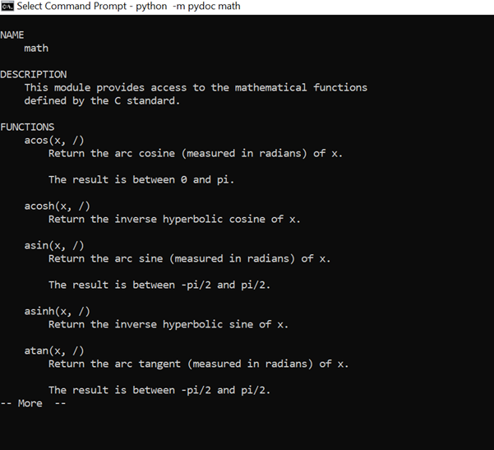

Pydoc shows us just a sample of what the math module can do, with many more functions viewable after the first page.

 In our next example, we used the keyword function to search “mail”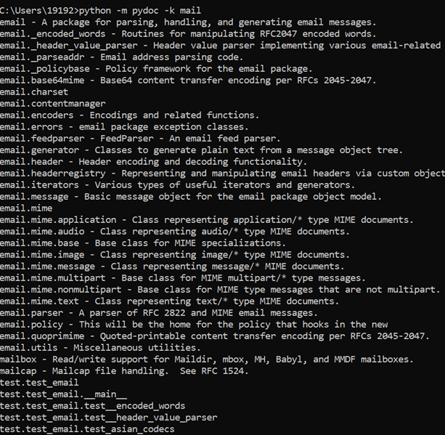

 In our next example we will browse the python index, which is automatically opened for us by the following:

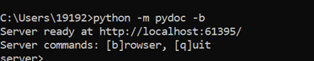

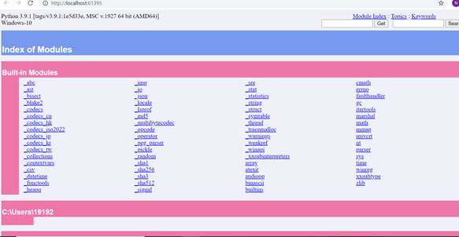

The index lists different modules and packages in Python, when we follow the links we get a more in depth view:

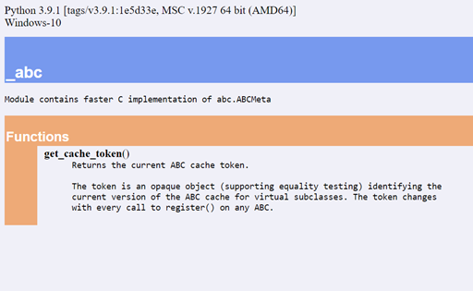

For the final example, we will see what the pydoc module can do for a program from the midterm. The code below is saved in a folder py4e on my desktop and named count.py

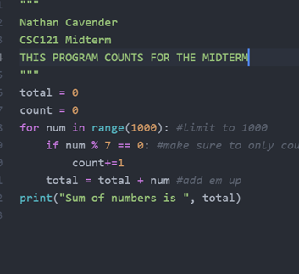

Pydoc runs and prints the following:

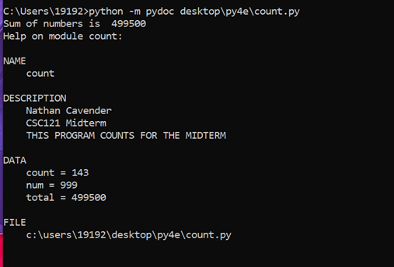

MULTIPLE CHOICE QUESTIONS:

Which pydoc function allows you to search for all modules for a keyword?

A) pydoc +k <keyword>

B) pydoc -key <keyword>

C) psyduck =k <ketchum>

D) pydoc -k <keyword>

What code will allow you to view documentation in a browser at

http://localhost:121/ ?

A) pydoc -v 121

B) pydoc -k 121

C) pydoc -n 121

D) just open the browser and type http://localhost:121/